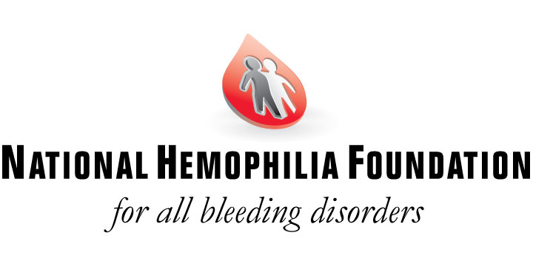
2021 Kevin Child Scholarship – Updated post COVID-19 process

Each year, the Kevin Child Scholarship is awarded to an exceptional student in memory of Kevin Child. As a child born with hemophilia in the late 1960s, Kevin had lived a life filled with challenges from the start. When he died of AIDS-related complications in 1989, he was just a few days short of his college graduation. Since hemophilia already presents a young person with challenges in life, the opportunity to obtain a higher education should never become an obstacle as well. In honor of Kevin’s legacy, the Child family hopes this scholarship program will provide some assistance for students striving to acquire a higher education.

WHO IS ELIGIBLE?
Scholarship applicants must be individuals diagnosed with either hemophilia A or B, and a high school senior with aspirations of attending an institute of higher education (college, university or vocational-technical school), or a college student already pursuing a post-secondary education. If selected for the KCS award, the award recipient can only receive the award once.

*HOW TO APPLY?
Interested students will need to complete the attached application and submit a current ‘official’ transcript of their grades along with one ‘letter of recommendation’ from a person familiar with their personal and academic achievements (ex. a teacher, or a mentor). Letters of recommendation written by anyone who may be related to the applicant will not be accepted.

Considering NHF’s physical office closure and possible school closures across the US, ‘official’ transcripts of grades will be accepted by email. Please email Angelina Wang of NHF should you or your school need to forward your transcript separately from your application, or if there should be any additional concerns about whether your transcript is ‘official’.

All fully complete KCS applications must be emailed directly to [awang@hemophilia.org] by no later than 5:00 PM Eastern on Monday, August 2, 2021 to be considered for this year’s Kevin Child scholarship award.

HOW IS THE AWARD RECIPIENT SELECTED?
The Kevin Child Scholarship recipient is selected on the basis of the applicant’s academic performance, participation in school or community activities and a personal essay detailing their educational and future career goals. A committee consisting of members of the Child Family will collectively decide upon the Kevin Child Scholarship award recipient. No staff member nor representative of the National Hemophilia Foundation participates in the award selection process.

FOR MORE INFORMATION
For additional questions, please email Angelina Wang at NHF (awang@hemophilia.org). When submitting a question by email, kindly add “KCS 2021” to your email subject line. To contact Mary Child Smoot, please email (smooter@aol.com).

KEVIN CHILD SCHOLARSHIP APPLICATION
Deadline: Submit via email by August 2, 2021

APPLICANT DATA (Please print clearly)

NAME: Last ________________________ First_____________________ MI _____

ADDRESS: Street Address ______________________________________Apt.________

City_________________________ State ______________ Zip __________

PHONE:( ) _______ - ________ Email: _____________________________________

DATE OF BIRTH: ____/____/_______ (MM/DD/YYYY)

Which type have you been diagnosed with? Hemophilia A Hemophilia B

What is the name of your primary care physician? __________________________

Address_________________________________ City _______________________

State ___________________ Zip___________ Phone: () _______ - ________

Are you affiliated with an NHF Chapter? Yes, which one? ____________________
No

How did you hear about the Kevin Child Scholarship? ________________________

ACADEMICS

(Please check one): I am currently a High School Student – Grade Level________

College Student – Year ____________ Other (Specify)_____________________

What subjects have you found most interesting in your studies?

__________________________________________________________________

Do you feel your grades are indicative of your overall ability? Yes No

If “No”, then what were the factors that prevented you from doing better?
____________________________________________________________________________________________________________________________________

If you are still in high school, please indicate your college choices:

First choice: _______________________Second choice: _____________________

KCS 2021rev Pg. 1

If you are currently attending College/Vocational School, please state:

School: _____________________Location: ___________________ Year_______

While attending college, where will you live?

At home On campus With friends or relatives Other (specify) ________

What course of study are you pursuing, or will you pursue?

__________________________________________________________________

What special recognition have you received for outstanding schoolwork (e.g. Honor’s, prizes or scholarships)?
__________________________________________________________________

__________________________________________________________________

How do you intend to pay for college?
Parents Self Loan Scholarships Grants

ACTIVITIES & HONORS
List all school or community activities you have taken part in (e.g. Student government, sports, etc.) and the year in which you participated. Also, highlight any special awards, honors and offices held. (If you need additional space, please attach a separate sheet of paper.)

__________________________________________________________________

__________________________________________________________________

__________________________________________________________________

__________________________________________________________________

___________________________________________________________

___________________________________________________________

CERTIFICATION
By signing this application, you hereby attest that the information provided here is true and correct. Applications submitted without a signature will not be accepted.

Signature ________________________Print Name_________________________

Date ______________________

KCS 2021rev Pg. 2

PERSONAL ESSAY
Type or legibly print a 1-page essay detailing your occupational objectives and goals in life. How will the educational program you have planned meet the objectives you have described? (If needed, feel free to attach an additional page.)

KCS 2021rev Pg. 3

Final Checklist for the full KCS Application:
____A fully completed 3-pg application which includes a ‘Personal Essay’

____1 signed ‘Letter of Recommendation’ from an individual who is familiar with your personal
and/or academic achievements (ex. teacher or mentor)
____1 Current ‘official’ school transcript (needs to accompany the application or be emailed
separately).

Applicants will be responsible for ensuring that all items listed above are submitted by email to (awang@hemophilia.org) before 5:00 PM Eastern on Monday, August 2, 2021.

