Q1
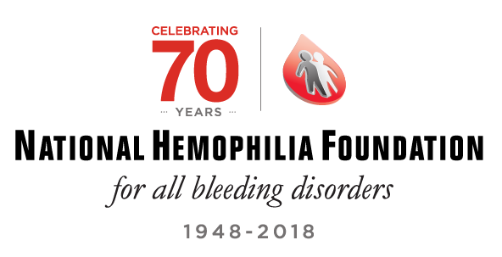

Q2 NHF Bridge Grant Application
For any questions please contact NHF's Research Department at
research@hemophilia.org

Q3 Applicant Information

Q4 Applicant's Last Name, First Name, Middle Initial, Degree
________________________________________________________________

Q5 Applicant's Position/Title at Institution
________________________________________________________________
________________________________________________________________
________________________________________________________________
________________________________________________________________
________________________________________________________________

Q6 Applicant's Work Mailing Address (Include Institution's Name)
________________________________________________________________
________________________________________________________________
________________________________________________________________
________________________________________________________________
________________________________________________________________

Q7 Applicant's Work Phone
________________________________________________________________

Q8 Applicant's Work Email
________________________________________________________________

Q9 Applicant's Home Mailing Address
________________________________________________________________
________________________________________________________________
________________________________________________________________
________________________________________________________________
________________________________________________________________

Q10 Applicant's Personal Mobile Phone
________________________________________________________________

Q11 Applicant's Personal Email
________________________________________________________________

Q12 Have you ever received grant from NHF previously?
- Yes (1)
- No (2)

Display This Question: If Have you ever received grant from NHF previously? = Yes

Q13 Which one and on what year?
- Judith Graham Pool (JGP)
- NHF-Novo Nordisk Career Development Award (CDA)
- Innovative Investigator Award (IIR)
- Bridge Award
- NHF-Shire Clinical Fellowship

Q14 Applicant Eligibility

Q15 Date R01 or R01 A1 was reviewed by the NIH study section (mm/dd/yyyy). Must be within the last 18 months.

Q16 Title of Proposed Project
________________________________________________________________
________________________________________________________________
________________________________________________________________

Q17 School Affiliation
________________________________________________________________
________________________________________________________________
________________________________________________________________

Q18 HTC Affiliation (if applicable)
________________________________________________________________
________________________________________________________________
________________________________________________________________

Q19 Research Category
- Basic
- Translational
- Clinical
- Health Services

Q20 Area of Research (diagnosis)
- Hemophilia A (FVIII deficiency)
- Hemophilia B (FIX deficiency)
- Inhibitors
- von Willebrand Disease
- Platelet Disorders
- Other factor deficiency
- Other ________________________________________________

Q21 For more information about this section please refer to the document titled
"Bridge Application Guidelines" found in the NHF Bridge Award webpage

Q22 Upload or drag the NIH Biosketch (maximum 5 pages and must include present position, training, publications, and other current funding)

Q23 Upload or drag the Institutional Commitment Letter from Department Chair or Division Chief (agreeing to institutional support of at least $50,0000)

Q24 Upload or drag the Budget AND Supplemental Form

Q25 Upload or drag first year budget from RO1

Q26 Upload or drag the specific R01 Aims section from the most recent relevant R01 submission, either initial application or A1 re-submission. Please do not submit the entire R01 application

Q27 Upload or drag the complete Summary Statement (from the original R01 application)

Q28 Upload or drag the Response to Critiques (including individual critiques from RO1 submission). Please redact scores.

Q29 Upload or drag written documentation from the NIH confirming your RO1 score was outside the fundable range.

Q30 Upload or drag Assurances and Certifications for Research Involving Humans-Animals -as applicable

Q31 Upload or drag completed Signature Page found in the award's web-page of NHF's website

Q32 STOP! This is the last page of the application. If you are ready to submit please select option below. If you are not ready, please go back and review your application.
You will have the opportunity to print out or download your application once it is submitted.
THANK YOU for applying!
- Yes, I am ready to submit my application (1)

